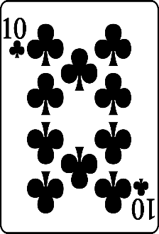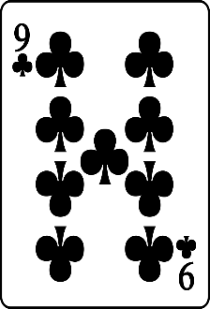c